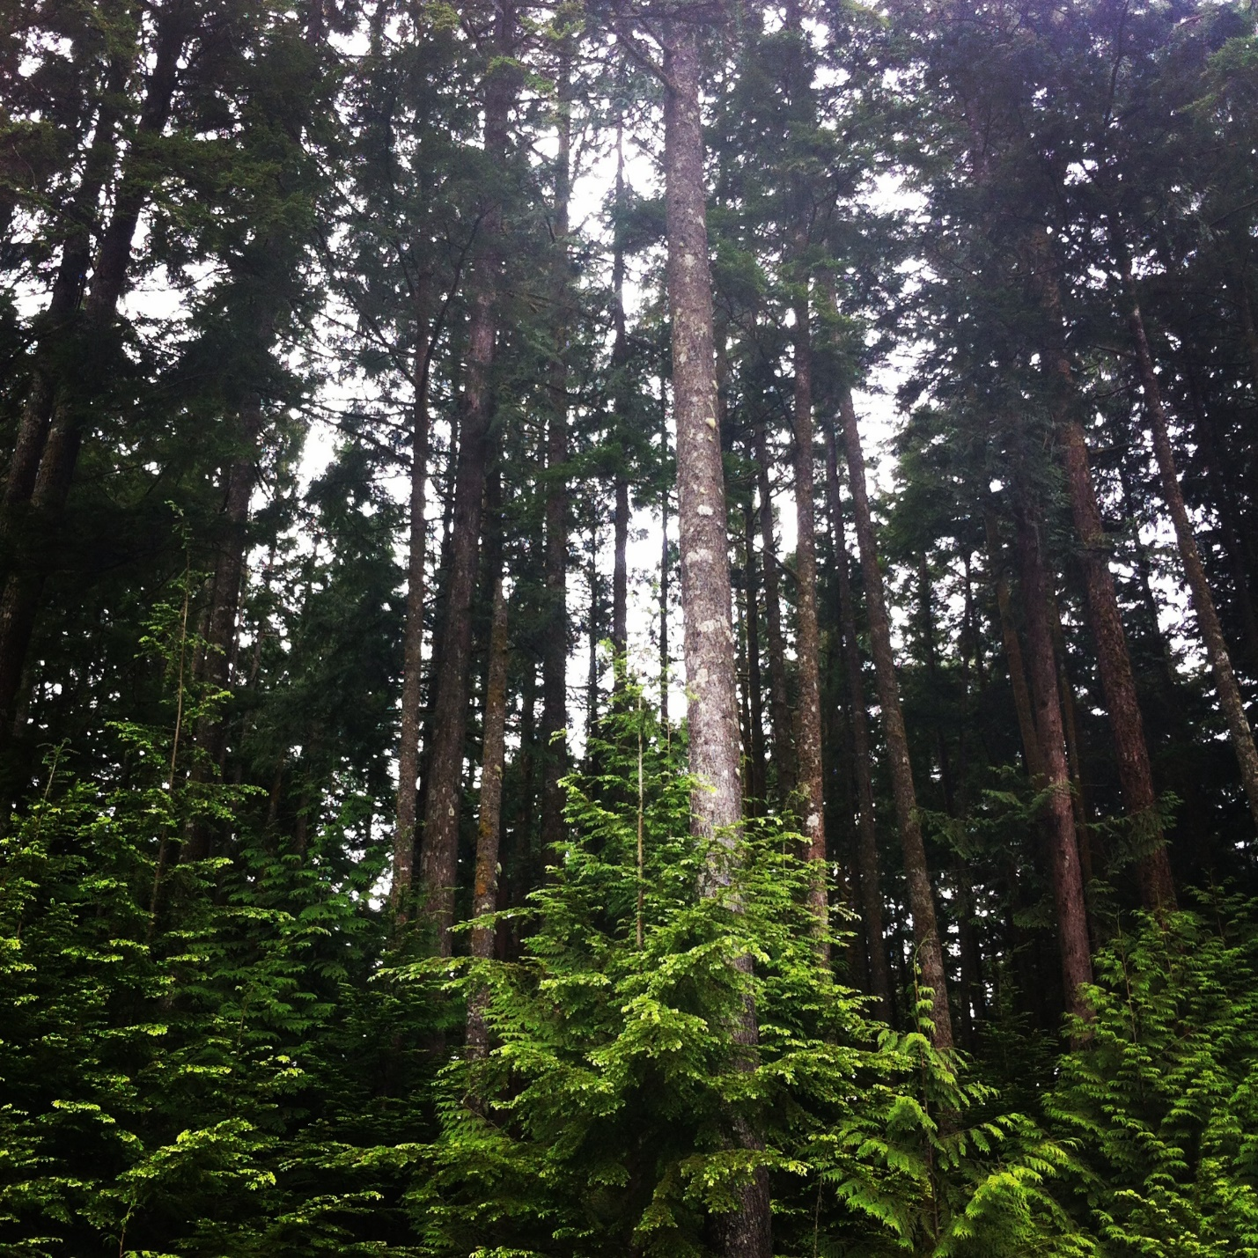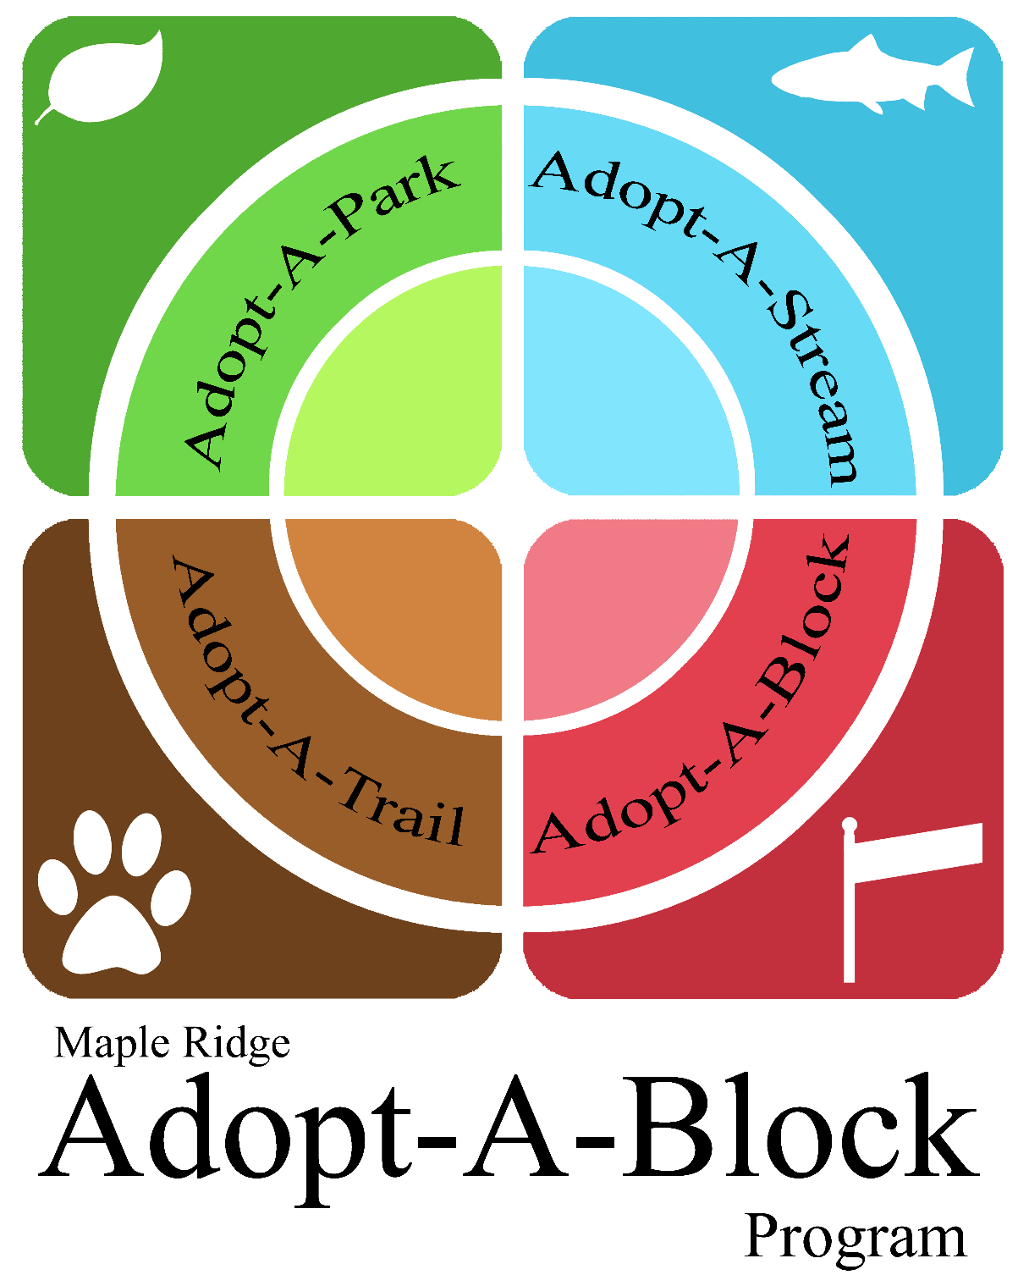

Registration Package:

Individuals and Families

The Adopt-A-Block Program is managed by the Alouette River Management Society

and funded by the District of Maple Ridge

**CONTACT INFORMATION**

Return your completed forms to Adopt-A-Block via:

1. Standard Mail:   
   Maple Ridge Adopt-A-Block Program  
   Alouette River Management Society  
   24959 Alouette Road, Maple Ridge, BC, V4R 1R8
2. Email (scanned documents):  
   adoptablock@telus.net

For questions and concerns, please call or e-mail:

Adopt-A-Block Program Coordinator at the Alouette River Management Society at:

**604-463-9699** OR **adoptablock@telus.net**

Any personal information collected on these forms will be managed in accordance with the Freedom of Information and Protection of Privacy Act. Direct enquiries, questions, or concerns regarding the collection, use, disclosure, or safeguarding of personal information associated with this form to:

**Alouette River Management Society, 24959 Alouette Road, Maple Ridge, BC, V4R 1R8**

W

elcome Participants! Maple Ridge wants to keep the community beautiful, and you can help by joining our program.

Adopt-A-Block is a stewardship program managed by the Alouette River Management Society and funded by the District of Maple Ridge that allows participants to take an active role in keeping their community clean and safe. Adopt-A-Block is simple: participants take care of their adopted location by picking up litter and the Alouette River Management Society provides cleaning supplies, safety information, and garbage removal.

This package, for individuals and families, contains forms that must be completed and returned to the Alouette River Management Society, as below.

Thank you to the families, individuals, schools, churches, service clubs, special interest groups, and local businesses who are active in the Adopt-A-Block program and help keep our streams, parks, blocks, and trails clean. Your efforts are appreciated!

Sincerely,

The Alouette River Management Society

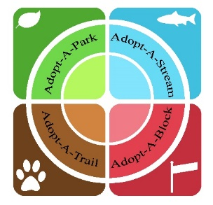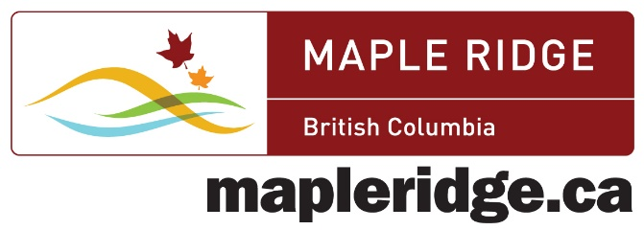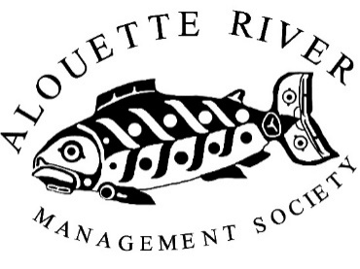

**REGISTRATION PACKAGE: INDIVIDUALS AND FAMILIES**

**ADOPT-A-BLOCK APPLICATION**

**Individual or Family Contact Information**

Individual/family name: _______________________________________________

Address: ___________________________________________________________

City: _______________________________________________________________

Postal code: ________________________________________________________

Phone: ____________________________________________________________

Email: _____________________________________________________________

Preferred contact method: Telephone E-mail Standard Mail

How did you hear about Adopt-A-Block? Newspaper Online Street Sign

**Organization Information**

Maple Ridge Adopt-A-Block Program

Alouette River Management Society

24959 Alouette Road, Maple Ridge, BC, V4R 1R8

**Adoption Type and Location**

Adoption type: Block Stream Trail Park

Describe preferred adoption location (be as detailed as possible, e.g. 999 Avenue: 21 Street to 45 Street)

___________________________________________________________________

___________________________________________________________________

I consent to be publically recognized on a municipal street sign: YES NO

**STATEMENT OF COMMITMENT**

**Individual or Family**

The individual or family agrees to:

1. Remove litter for a minimum of 1 year as follows:

• Stream: four times per year

• Park or trail: minimum two times per month (adopted section only)

• Block: once per month

1. Ensure appropriate tools and equipment are used during clean up and avoid direct contact with potentially hazardous or injurious objects. Items such as syringes, condoms, and animal parts must not be touched. Hazardous litter and exceptionally heavy or unyielding objects are to be reported immediately to the District of Maple Ridge, at **604-463-5221**
2. Report participant injuries incurred during cleanup activities to the Program Coordinator within two working days of the incident. Include:

a) Name of injured person

b) Time and date of incident

c) Nature of injury

d) Incident Details

e) Hospital or Clinic Attended

**Adopt-A-Block Program Coordinators and Management**

Adopt-A-Block Program Management agrees to:

1. Supply operating materials
   1. Adopt-A-Block will provide cleanup equipment (grabbers and bags) that can be signed-out at the Maple Ridge Leisure Centre OR ARMS. Please return equipment during operating hours on same day as sign-out. Vests provided for group cleanups; please arrange in advance.
2. Arrange for removal and disposal of large materials
   1. If you come across large or uncommon debris during your cleanup that is too big to fit in your standard garbage or recycle receptacles, please call **604-463-9699** or email **adoptablock@telus.net** and Adopt-A-Block will arrange to have the items picked up
3. Provide third party liability insurance for injury and property damage arising from activities of this program. Such insurance does not cover any loss suffered by participants in the program.

At no time is the safety of a volunteer to be compromised in the performance of cleaning activities.

I have read and understood this statement of commitment, and I agree to the terms of participation.

Adopter’s signature: __________________________________________________

Parent/Guardian Signature (if adopter is under 16 years of age): ______________________

Date: ______________________________________________________________

ARMS’ signature: The Alouette River Management Society

Date: Through December 2014

**WAIVER OF LIABILITY – RELEASE AND INDEMNITY**

It is important that ARMS volunteers understand the extent to which ARMS provides insurance coverage for liability and personal injury/illness. Complete and sign the following prior to volunteering with Adopt-A-Block.

I, the Adopt-A-Block applicant, wish to participate in the Adopt-A-Block Program through the Alouette River Management Society (ARMS) and assist ARMS in providing services to the community as a volunteer and without any expectation of profit or gain. In exchange for the opportunity to participate in the delivery of ARMS’ programs and services, I agree to the following:

1. I acknowledge and agree that I am participating in the ARMS volunteer program solely upon my own initiative and at my sole risk. I recognize that certain risks may be inherent in the provision of volunteer services and I voluntarily assume those risks.
2. I agree that ARMS will not be required to compensate me for any harm or loss suffered as a result of my participation in the provision of volunteer services, whether that be physical harm such as illness, injury, or death, harm to my reputation, or loss of or damage to personal property owned or used by me in the provision of volunteer services.
3. I agree not to take legal action against ARMS for any harm of loss suffered by me in connection with the provision of volunteer services regardless of how that harm or loss occurred or why it happened.
4. I also relinquish any right I might have to claim compensation from ARMS as a result of legal action taken by their parties as a result of injury, illness or death suffered by me or as a result of any loss of or damage to personal property owned or used by me in the provision of volunteer services.
5. Any reference to ARMS in this document shall include the Alouette River Management Society and all associated charities, divisions, and unincorporated associations, as well as all officers, employees and volunteers of any of them.
6. I fully understand and agree to the terms set out in this document and I am signing it voluntarily, recognizing that this document may be relied upon by ARMS in the event that court proceedings are taken against it by me or any third party.

I have read and understand the above conditions of volunteer service:

Adopter’s Signature: _________________________________________________

Parent/Guardian Signature (if adopter is under 16 years of age): ______________________

Date: ______________________________________________________________

*Volunteer must notify the program coordinator within 24 hours of emergency at 604-463-9699 or voluncomm@alouetteriver.org

**PERSONAL LIABILITY**

You are protected from civil liability for injuries or damage to the person or property of others, subject to the following general conditions:

1. You are volunteering on an Adopt-A-Block task

2. You limit your actions to the Adopt-A-Block duties

3. You perform your Adopt-A-Block tasks in good faith and do not act in a manner that is reckless or with the intent to unlawfully inflict harm to others.

**Motor Vehicle Liability**

If you use a personally owned vehicle in the course of your duties, you are required to have automobile liability insurance to provide primary coverage for any accidents involving that vehicle.

**Volunteer Injury Coverage**

Workers’ compensation is not provided. ARMS has insurance for volunteers. If you are injured in a private vehicle, the owner’s insurance is responsible for your medical bills.

**Reporting Responsibility**

If you are involved in an accident or exposed to a potential liability situation while performing assigned duties, you must inform your group contact before the end of your current clean up shift.

In case of serious emergency (including a medical emergency) please call 9-1-1.

I have read and understand the above conditions of volunteer service:

Adopter’s Signature: _________________________________________________

Parent/Guardian Signature (if adopter is under 16 years of age): ______________________

Date: ______________________________________________________________

**SAFETY GUIDELINES**

**Who is the contact?**

Determine a representative from your group to be the contact person.

**Role of the contact:**

The contact person is responsible for submitting all required documentation and serves as the liaison between the Alouette River Management Society and any volunteers represented. The contact is also responsible for reminding volunteers to use good judgment and safe practice during cleanup activities. The items in this guide should be discussed with the group prior to each clean up event. Remember Safety First! Under no circumstance is the welfare of a participant to be compromised during cleanup activities.

**Walking on Streets:**

• Work on one side of the street at a time.

• Pick up litter walking against traffic. This ensures all volunteers are facing oncoming traffic and are aware of dangers.

**Volunteer Clothing**

• Always wear reflective / bright clothing

• Always wear suitable footwear (boots or closed-toe shoes)

• Dress appropriately for the weather

• Avoid use of headphones or restrictive clothing

**Emergencies**

• Keep a cell phone handy or know where the nearest phone is

• Have transportation available

• Know the quickest route to the nearest hospital in case of a serious injury

**General Tips**

• Avoid horseplay while working

• Prohibit alcohol and/or illegal drugs

• Keep an adequate supply of water

**SAFETY CHECKLIST**

* DISCUSS THE CLEAN UP ROUTE.
  + Take note of any areas of concern or potential danger, such as high traffic areas or locations where there is limited vision of approaching traffic.
* SUPERVISE MINORS.
  + Ensure a responsible adult is present to supervise minors.
* PREPARE YOUR MATERIALS.
  + Make sure you have all tools and materials required to complete your task safely and efficiently. Check that your equipment is in good working condition.
* REVIEW SAFETY INSTRUCTIONS WITH PARTICIPANTS:
  + Watch for cars and other vehicles.
  + Obey traffic regulations and use marked crosswalks
  + Handle dangerous refuse carefully
* Dangerous refuse such as broken glass or other sharp objects must be handled carefully to avoid injury. Litter pickers are provided for this purpose. It is a good idea to designate one person to pick up dangerous items with a litter picker, especially if children work in your group.
* Volunteers must not handle hazardous litter
* Objects containing corrosive chemicals (e.g. car batteries) or objects that may carry harmful bacteria or disease (e.g. dead animals, syringes, etc.) should not be touched. Flag the location where items are found and contact the District for proper collection and disposal
* Report pollution incidents and water-quality complaints to the Environment Section of the District of Maple Ridge at **604-467-7499** or **604-463-5221 ext. 5619** during working hours. To report outside regular working hours (Monday to Friday 8am-4pm) calling the Provincial Emergency Program (PEP) at **1-800-663-3456** will result in the complaint being forwarded to either Environment Canada or the District 24 hour line.  An on-call staff member will pick it up, and either call Environment staff for help, or go out to investigate on their own.
* Never reach blindly to pick up an item.
* Work in pairs or teams.

Remember Safety First!